**77018143764**

**800402400168**

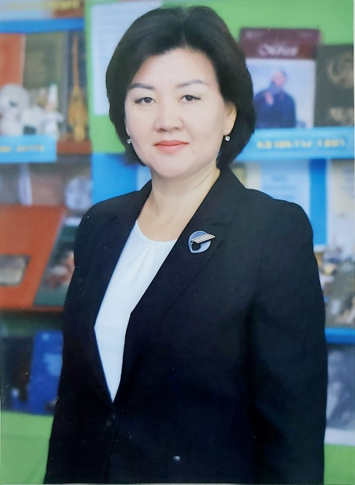

**КОНЫСБАЕВА Галия Кемелбаевна,**

**Т.Рысқұлов атындағы орта мектебінің ағылшын тілі пәні мұғалімі.**

**Алматы облысы, Еңбекшіқазақ ауданы**

**TEACH, ENGAGE, INSPIRE: A TREASURE TROVE OF DIDACTIC MATERIALS FOR ENGLISH LESSONS**

**Introduction**

This guide provides English language teachers with innovative strategies and practical methods to create engaging and effective lessons. It emphasizes interactive learning, fostering student motivation, and utilizing modern teaching tools to enhance communication skills. Designed for both new and experienced educators, this resource offers adaptable approaches for different classroom settings.

**Key Objectives:**

1. Foster student-centered learning with interactive and immersive activities.
2. Develop critical language skills (speaking, listening, reading, writing, grammar, and vocabulary).
3. Incorporate technology and digital tools for more engaging lessons.
4. Apply differentiated instruction to cater to various learning styles and proficiency levels.
5. Utilize project-based learning to improve student collaboration and creativity.
6. Implement effective assessment techniques to measure and enhance learning outcomes.

**Contents**

**1. Engaging Lesson Starters & Icebreakers**

* Interactive Storytelling – students create short stories collaboratively.
* Question Roulette – rapid Q&A sessions to stimulate discussion.
* Role-Play Introductions – practicing real-life conversational skills.
* Word Association Games – enhancing vocabulary recall in a fun way.
* Mystery Challenge – problem-solving tasks to encourage logical thinking.

**2. Dynamic Vocabulary and Grammar Approaches**

* Gamification of Grammar – interactive quizzes and board games.
* Lexical Approach – teaching vocabulary in meaningful contexts.
* Grammar in Action – role-playing scenarios incorporating grammatical structures.
* Context-Based Learning – using authentic materials like news articles and blogs.
* Multisensory Techniques – utilizing visuals, gestures, and music to reinforce learning.

**3. Speaking & Listening Enhancement**

* Conversational Circles – structured peer discussions on various topics.
* Real-World Listening Practice – analyzing podcasts, TED Talks, and interviews.
* Impromptu Speech Challenges – boosting confidence in spontaneous speaking.
* Pronunciation Drills with Phonetics Focus – improving articulation and fluency.
* Interactive Drama and Role-Plays – applying language in simulated real-life situations.

**4. Reading and Writing Skills Development**

* Close Reading Strategies – deep analysis of texts for comprehension.
* Creative Writing Workshops – developing storytelling and persuasive writing skills.
* Summarization & Paraphrasing Techniques – enhancing text-processing skills.
* Collaborative Blogging – students create and manage digital content.
* Email and Formal Letter Writing – preparing students for real-world communication.

**5. Digital Tools & Interactive Assessments**

* Kahoot! and Quizizz for Instant Feedback – game-based assessments.
* Project-Based Learning – integrating technology for student-driven projects.
* Self-Assessment and Peer Reviews – fostering autonomy and collaborative evaluation.
* Online Learning Portfolios – tracking progress through digital journals.
* Augmented Reality (AR) & Virtual Reality (VR) in Language Learning – enhancing engagement through immersive experiences.

**Conclusion**

Innovative language teaching requires flexibility, creativity, and integration of modern methodologies. This guide equips teachers with the tools to create engaging, student-centered lessons that not only improve linguistic competence but also enhance critical thinking, problem-solving, and collaboration. By applying these strategies, educators can foster a love for language learning and prepare students for real-world communication challenges.

With the right approach, teaching English can become an exciting and dynamic experience, inspiring both teachers and students to explore the limitless possibilities of language acquisition.